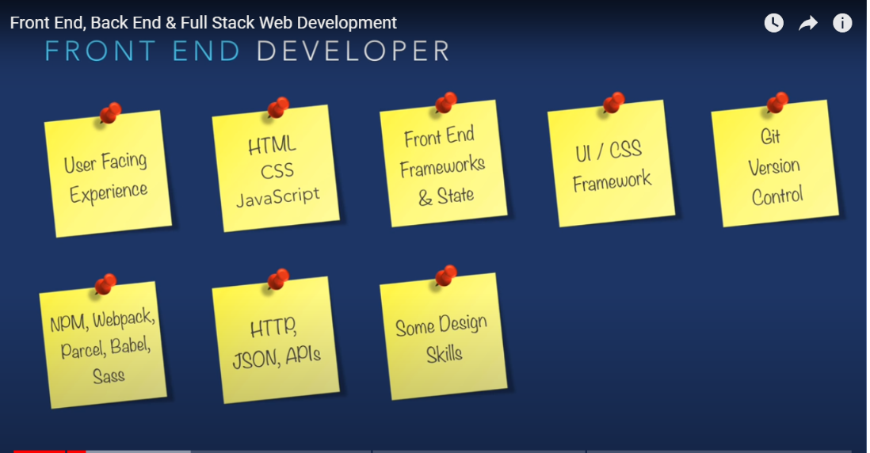

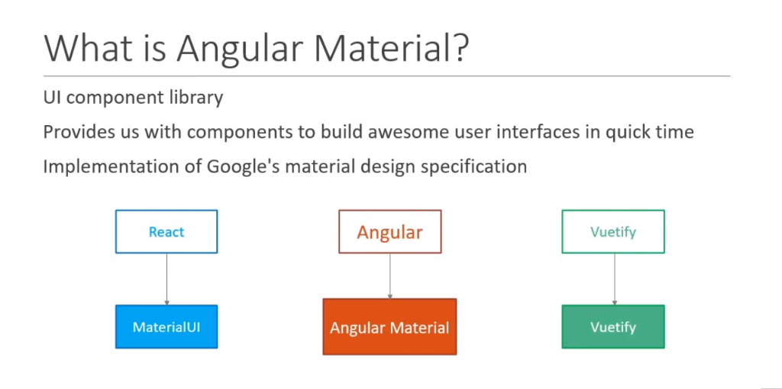

Forms

1.Template Driven Forms

2.Reactive Forms

3.Forms